

**جــامـعـة الإسراء الخــاصــة**

**كـليـة تكـنولوجيـا المعلومـات**

**Isra University**

**Faculty of IT**

**Second Semester 2023/2024**

|  |  |  |
| --- | --- | --- |
| Course Title:Database | Course No.:  06013130 | HW No :  2 |
| Submitted to: Dr. Maher Abuhamdeh | | |
| Student Number:  AB1199 | Student Name:  حمزة خالد مسلم | Date:  14 / 05 / 2024 |

You need to solve Exercise 2 up to Exercise 7

Using oracle live

And send me the screen shoot for your works

**Exercise 2 :**

**employee**

|  |  |  |
| --- | --- | --- |
| Aid | name | gender |

* Type of gender is number

1. Create the above table
2. Add attribute ‘dob’ (date of birth) to the table
3. Increase the capacity of name attributes by 10 characters
4. Change type of gender to char(1)
5. Rename attribute ‘name’ to ‘empname’ 6- Rename table to ‘emp’

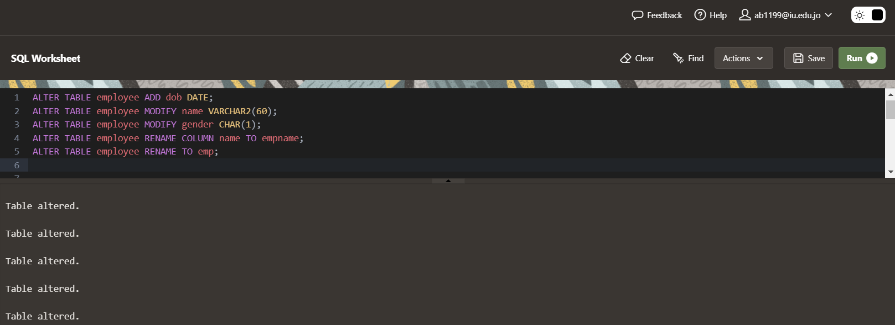صورة تحتوي على نص, برامج الوسائط المتعددة, برمجيات, برنامج الرسومات

تم إنشاء الوصف تلقائياً

**Exercise 3 :**

**Create the following tables. Take the following notes into consideration.**

* **You need to think of the appropriate primary key for each table**
* **Use the best way for defining primary keys (using a constraint)**
* **Give the constraints a meaningful name**

**course**

|  |  |  |
| --- | --- | --- |
| cid | Cname | Credits |

**prerequisite**

|  |  |
| --- | --- |
| cid | requisitecid |

**section**

|  |  |  |  |  |  |  |  |  |
| --- | --- | --- | --- | --- | --- | --- | --- | --- |
| secid | crsid | Semester | Year | hallNo | instID | fromTime | toTime | days |

**bank**

|  |  |
| --- | --- |
| bankid | name |

**bankbranch**

|  |  |  |
| --- | --- | --- |
| bankid | branchid | Address |

**borrowBook**

|  |  |  |  |
| --- | --- | --- | --- |
| bookID | copyNum | customerID | borrowDate |

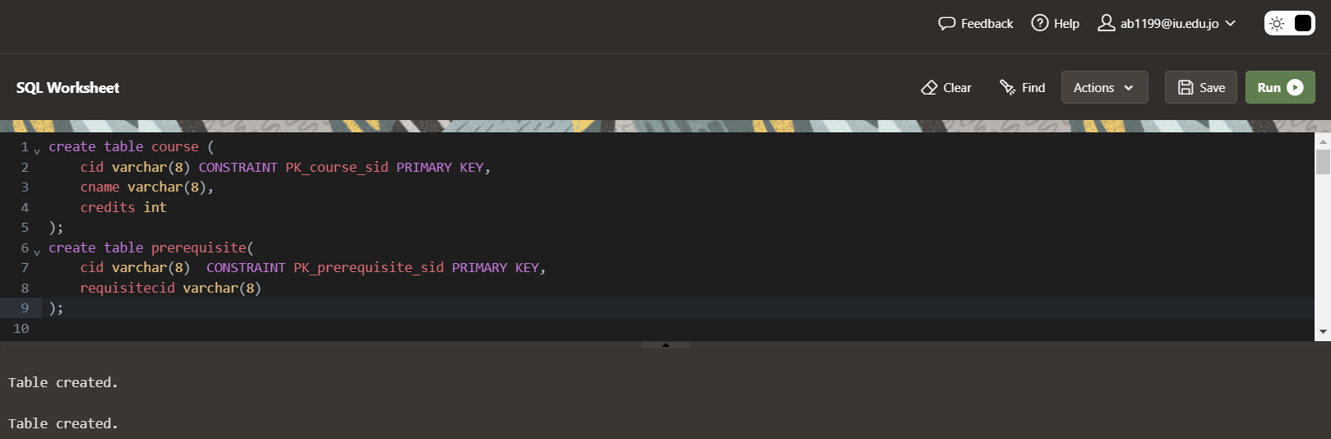

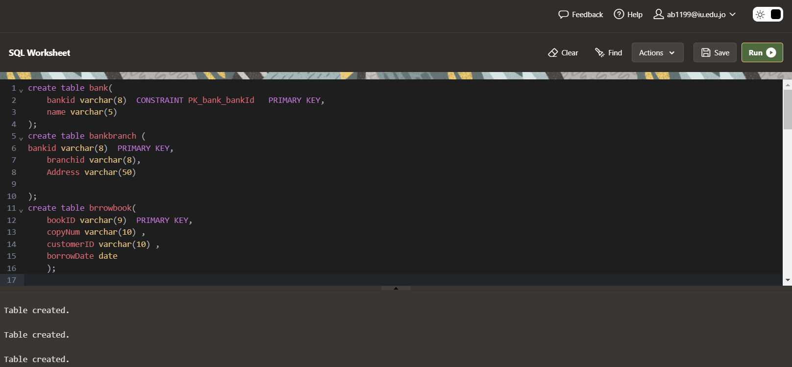**صورة تحتوي على نص, برمجيات, برامج الوسائط المتعددة, وسائط متعددة

تم إنشاء الوصف تلقائياً**

**Exercise 4 :**

Create the following tables using create table statement, and then use alter table statement to define the primary key of tables. Make sure you use constraints in the alter table.

**library**

|  |  |
| --- | --- |
| Libid | Name |

**libraryBranch**

|  |  |  |
| --- | --- | --- |
| libid | Branched | Address |

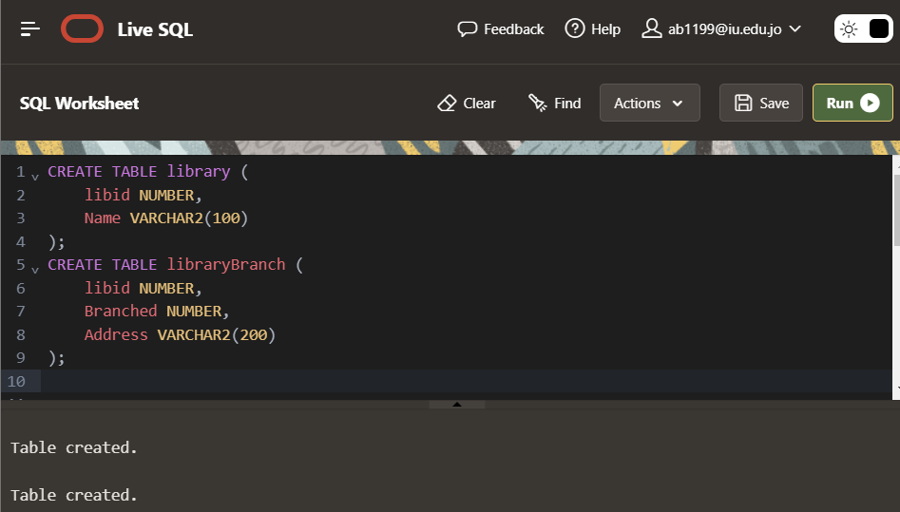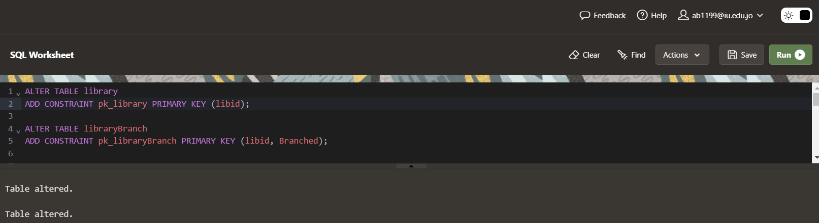

**Exercise 5 :**

**car**

|  |  |  |  |
| --- | --- | --- | --- |
| plateNo | Model | year | color |

1. Create the previous table such that ‘model’ is the primary key
2. Now, the primary key ‘model’ is not the correct primary key, so remove the primary key
3. Use alter table to define the correct primary key of the table
4. Use alter table to make the attribute ‘model’ not null
5. Use the view ‘user_constraints’ to retrieve the constraint name that represents the primary key of the table

صورة تحتوي على نص, لقطة شاشة, برمجيات, برامج الوسائط المتعددة

تم إنشاء الوصف تلقائياً

**Exercise 6 :**

**hall**

|  |  |  |  |
| --- | --- | --- | --- |
| hallNo | hallType | macCapacity | dataShow |

1. Create the above table such that hallNo is the primary key
2. Define a check constraint which makes the allowed values for hallType ‘Theory’, ‘Lab’
3. Define a check constraint that makes sure maxCapacity values are always greater than zero
4. Define a check constraint that makes the allowed values for datashow 0 or 1
5. Remove the constraint you created in the previous question and make a new constraint that makes the allowed values for datashow ‘true’ or ‘false’

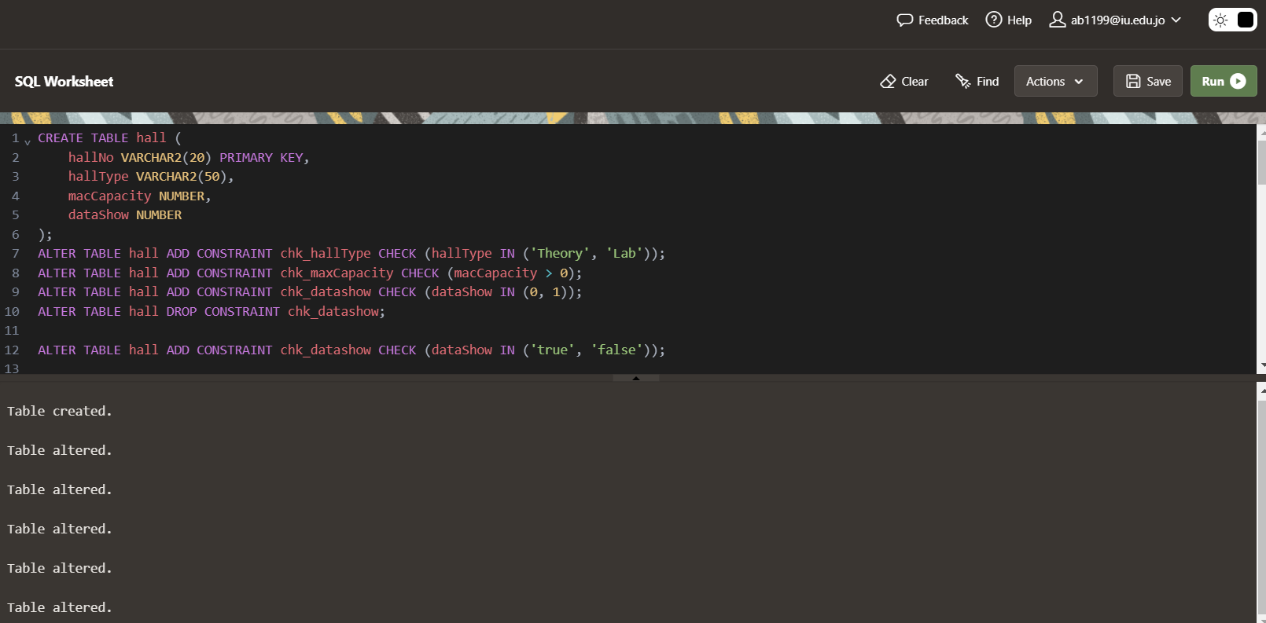

**Exercise 7 :**

**animal**

|  |  |  |  |
| --- | --- | --- | --- |
| Aid | Type | Dob | cageNum |

**cage**

|  |  |  |
| --- | --- | --- |
| cageNum | Area | Location |

1. **Create the previous tables and make sure you define their primary keys**
2. **Insert 3 animals in table animals, use default date format and other date formats**
3. **Insert 3 cages in table cage**
4. **Make all tigers move to cage number 5**
5. **For cages located in ‘east’, increase their area by 10 square meters**
6. **If a cage area is greater than 100 square meters, then move it to ‘west’ location**
7. **Delete all animals that are older than 20 years**
8. **Delete all tigers if they live in cage 7 or cage 9.**

